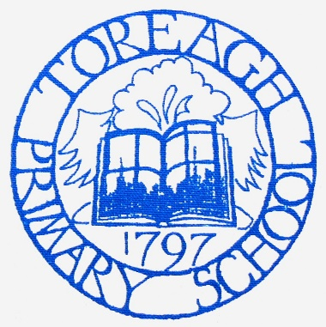
10

Principal: Miss C L Morrow
62 Raloo Road, Larne
BT40 3DU
Tel: 028 28260617
Email: info@toreaghps.larne.sch.ni.uk

31st December 2020

School Closure Information
Please find outlined below the information that you need to know in relation to the closure of schools announced by Minister Weir earlier today. Please be advised that this information may change if guidance is updated over the coming days. Should this be the case, an updated copy of this letter will be sent out to parents.
As always, from the outset, can I continue to thank you for your ongoing support at this time. Although this school year has been a challenging one it has been made much easier by the support you have all shown me and my staff. As with our previous restart plans, I want to assure you that any decision being taken today has a reason behind it.
The following has been discussed by Minister Weir, DE, EA and the Teaching Unions. Please read this carefully:
- Remote Learning Start Date
All children will begin their remote learning on Tuesday 5th January. School was due to start back on Monday 4th January, however, the Department of Education has allowed schools to take their first day of term as a preparation day for the planning for remote learning. Therefore school will not be open for any children on Monday 4th January.
- Remote Learning Activities
Activities will be placed on the Home Learning Section of the website as has been done previously. Provision will be made for those who do not have access to the internet.
I would ask that you keep your child’s teacher informed of how your child is getting on. This should be done each day: a short response on the home learning page or an email is enough eg. all good today or John found the Maths difficult etc.

- Provision for Key Worker Children and Vulnerable Children
Our provision for Key Worker children will begin on Tuesday 5th January 2021. Please be advised of the following information before asking for Key Worker provision:
• Key Worker provision will be supervised learning only. Key Worker Children will complete the same activities as children learning remotely from home. No additional face-to-face teaching will take place.
• School start and finish times will remain unchanged.
• BOTH PARENTS must be key workers in order to apply for key worker provision (or 1 parent in a single parent household).
• As per Department of Education guidance, Key Worker provision should only be applied for if all other childcare options have been exhausted.
• Children attending school must wear school uniform.
• No school meals will be provided, and children must bring their break and lunch with them, each day.
As you will be aware, the community transmission of Covid 19 is currently extremely high. The Minister has closed primary schools next week in order to try to reduce transmission. With this in mind, please only apply for key worker provision as a last resort ( DENI ). This will allow us, as a school, to keep as many children and staff apart for a little while longer and, hopefully, ensure that transmission of the virus is kept low and that all staff would be available for a full restart on Monday 11th January 2021.
If you are a Key Worker and meet the criteria, please email me by Sunday ^{3rd} January at 12 noon. ( lmorrow225@c2kni.net)

- Primary 7 AQE
Early communication from the Department of Education stated that schools could decide to bring back examination years for face to face teaching. This is aimed at statutory examinations in post primary schools and therefore primary schools should not bring back P7 pupils. Therefore, P7 pupils will also be accessing remote learning from Tuesday 5th January.

I wish you all a very happy and peaceful New Year and look forward to welcoming all our children back to school in the very near future.

C L Morrow
Principal

