How to log in to our Home Learning section on website.
Go to our home page at www.toreaghprimaryschool.co.uk
Click on Pupils along the top tab bar.
Click on Home Learning. A screen like below will appear. Please enter password (sent to you in the text from school) then click Submit.
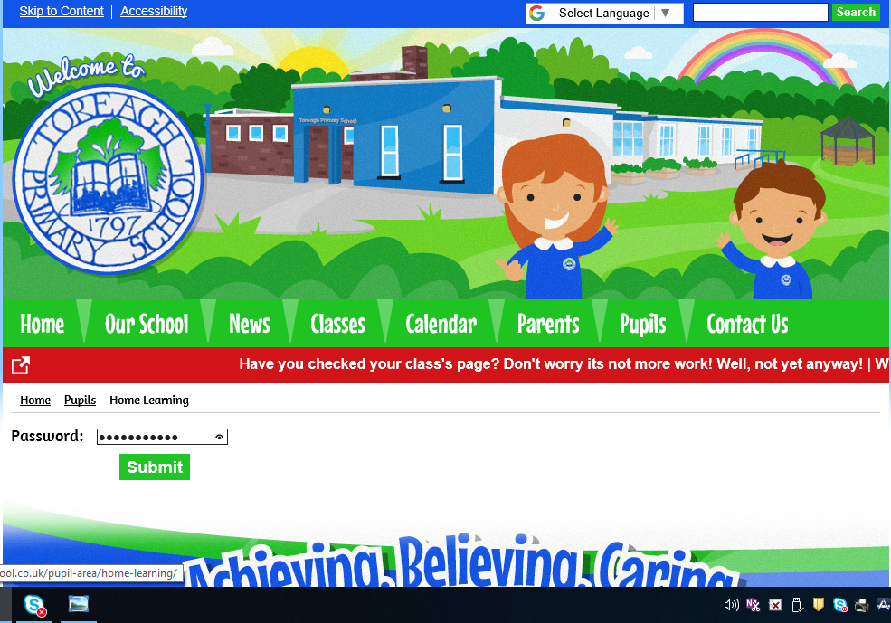

A page like this should appear and you should click on your specific class to see what the plan is for the day ahead.
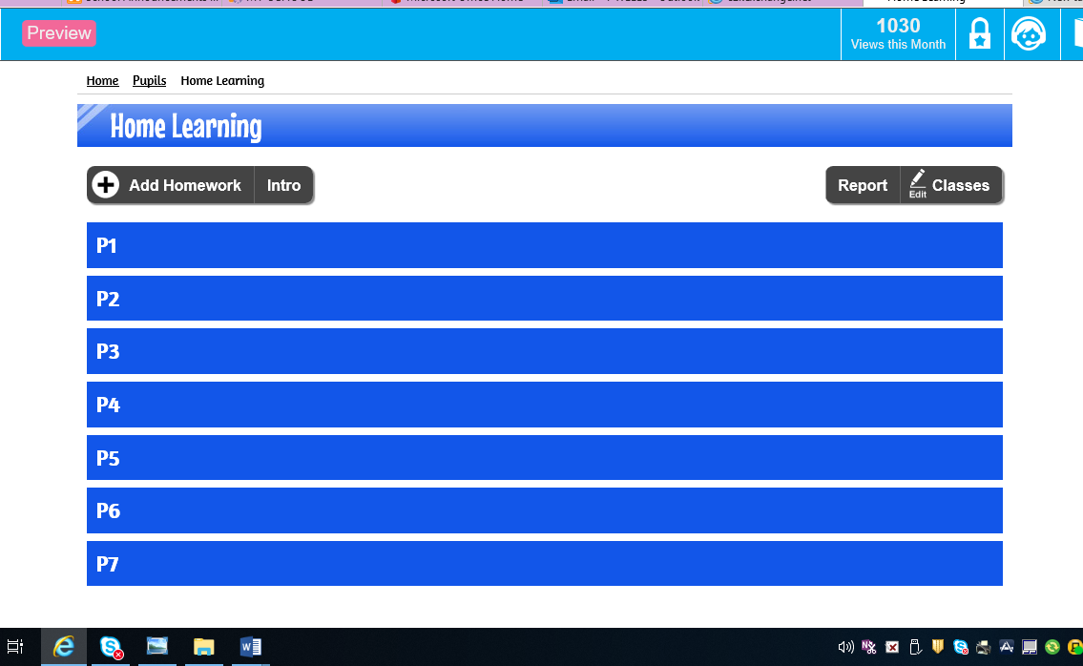
All teachers can be contacted at their email address given in the Home Learning folder on each class page, if you need help with a specific item on the Home Learning class areas. See example below.
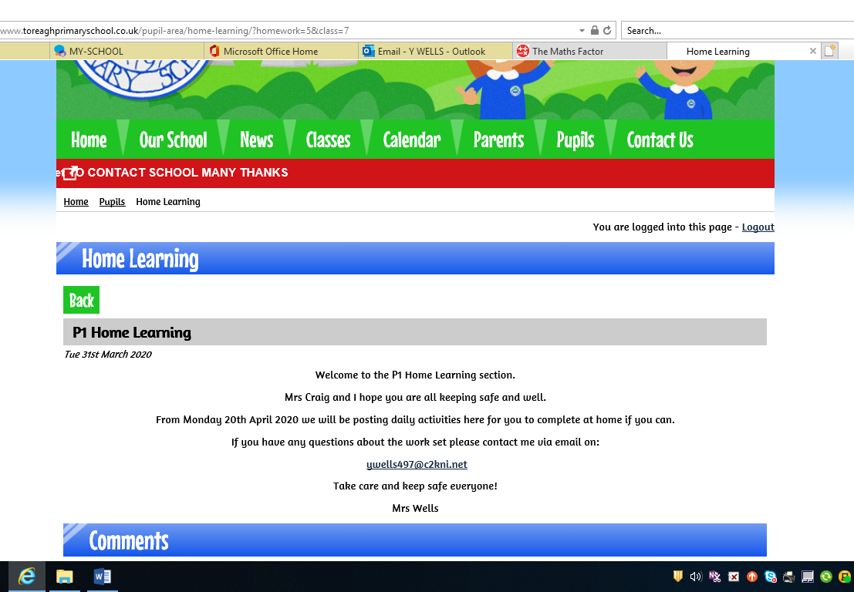
All work will be provided in a folder for each day of the week and dated with the appropriate date. See example below. Just click on the appropriate folder. However, everyone’s situation is different at the minute and as much as we encourage you do it on the day given, please complete it as and when suits you best.
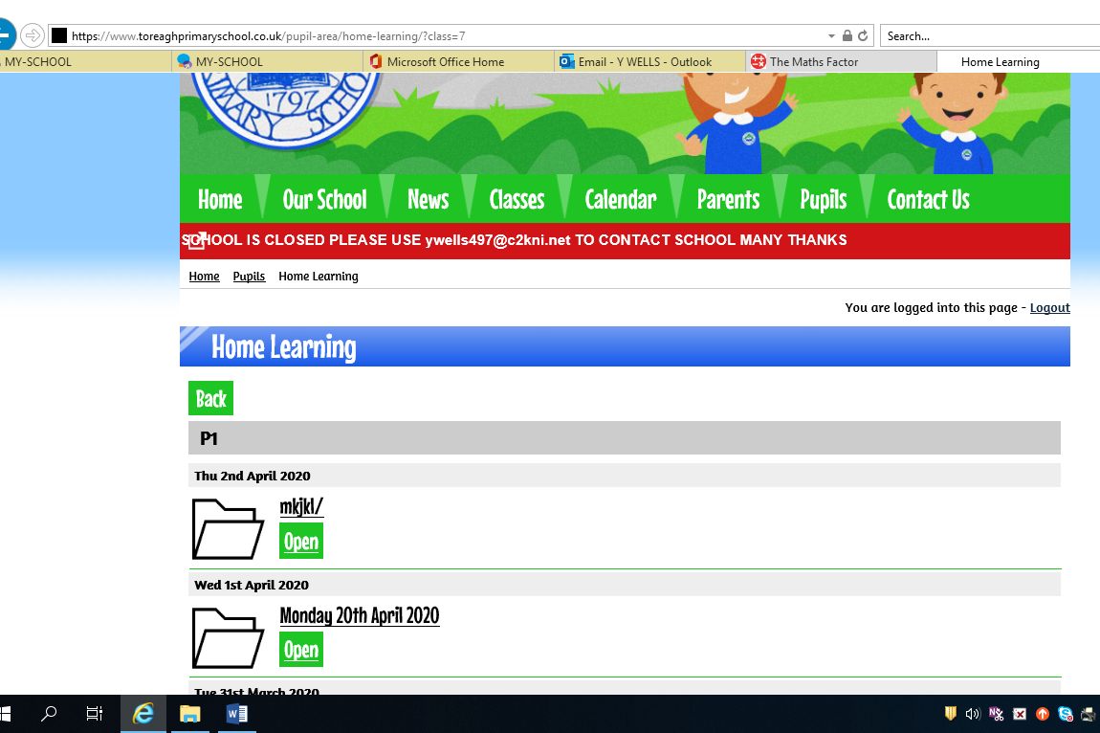
When you click on it the plan for the daily learning will appear like the example below. Follow it as best suits you. You can do it in the order that the teacher has set out for you or pick and choose your own order.
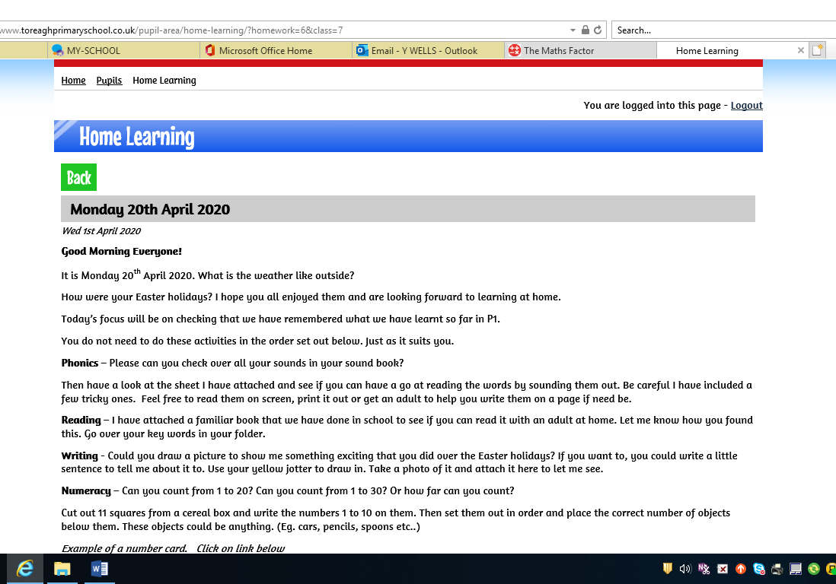

Any attachments will be listed at the bottom of the page.
When you have completed the work send your teacher your work either via their email address or on the comment section at the bottom of the page. This can be a photo of your completed work or some feedback on how you found the work or if you would like more help or guidance. Just fill in the details as is shown below and press Add Comment and your teacher will be able to see your work.
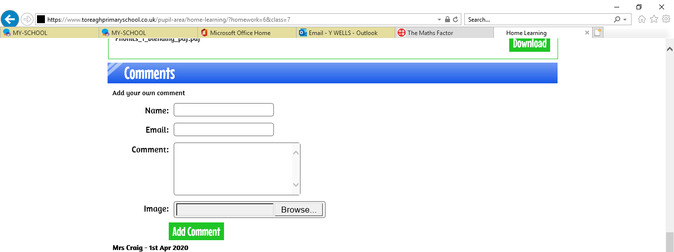

Last thing to do is then log out by clicking on it.
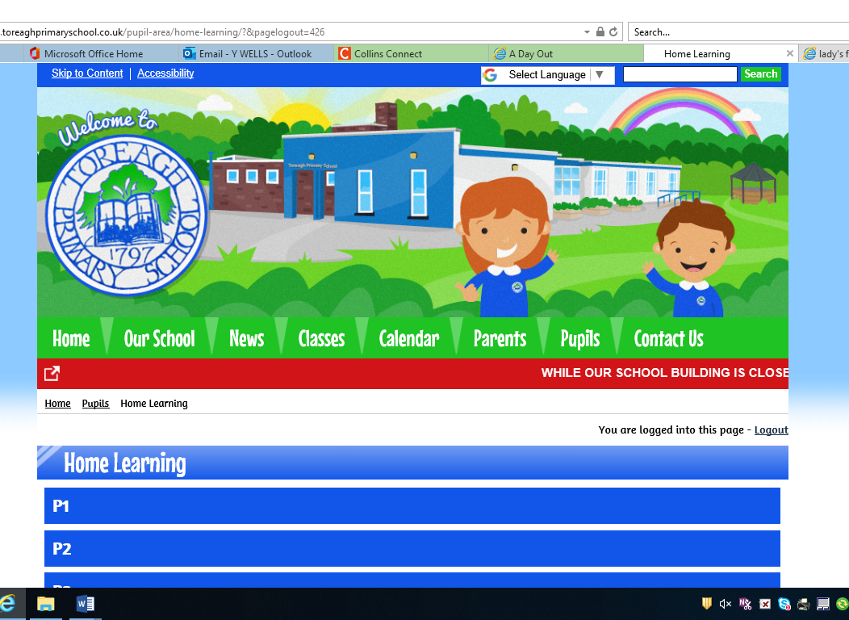

Please remember we are at the end of an email and will only be too happy to help or support you.
Happy Learning.

